Income Occupation Gender

Dataset: <https://www.kaggle.com/jonavery/incomes-by-career-and-gender>

In this dataset, we have the following attributes:

· Occupation- Job title as given from BLS.

· All_workers- Number of workers male and female, in thousands.

· All_weekly- Average weekly income including male and female workers, in USD.

· M_workers- Number of male workers, in thousands.

· M_weekly- Average weekly income for male workers, in USD.

· F_workers- Number of female workers, in thousands.

· F_weekly- Average weekly income for female workers, in USD.

Q. Find the top 10 occupations where average weekly income of females is greater

than that of males

source="inc_occ_gender.csv" F_weekly!=Na M_weekly!= Na | where M_weekly < F_weekly | Top F_weekly M_weekly by Occupation | sort -F_weekly -M_weekly| table Occupation F_weekly M_weekly

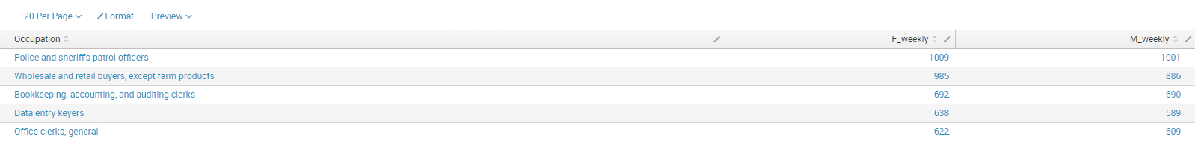

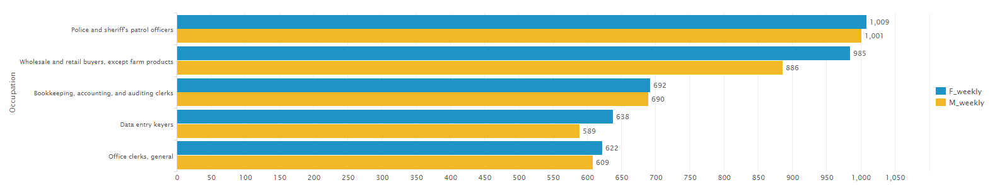

Q. Find top 5 occupations with highest number of male workers

source="inc_occ_gender.csv" Occupation!="ALL OCCUPATIONS" | sort -M_workers | head 5 | table Occupation M_workers

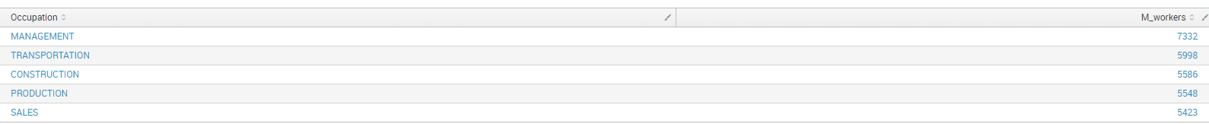

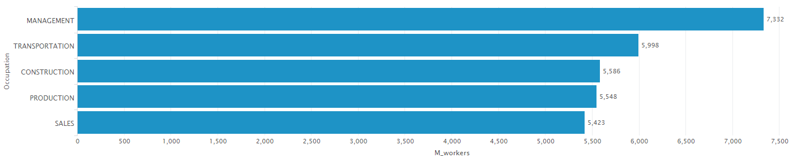

Q. Calculate the differences between income of males and females in the highest and lowest paid occupations.

Highest:

source="inc_occ_gender.csv" All_weekly!=Na M_weekly!=Na F_weekly!=Na | sort -All_weekly | head 1 | eval sal_diff=ABS(M_weekly-F_weekly) | table sal_diff

Answer: 415

Lowest:

source="inc_occ_gender.csv" All_weekly!=Na M_weekly!=Na F_weekly!=Na | sort +All_weekly | head 1 | eval sal_diff=ABS(M_weekly-F_weekly) | table sal_diff

Answer: 21

Q. Calculate the total number of occupations where males are paid higher than females but female workers are higher in number

source="inc_occ_gender.csv" M_weekly!=Na F_weekly!=Na Occupation!="ALL OCCUPATIONS" | where M_weekly>F_weekly AND F_workers>M_workers | stats count as Total

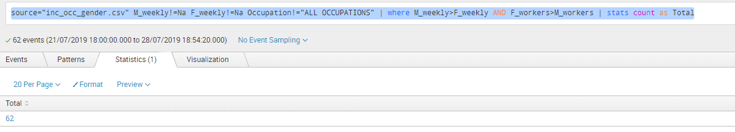

Q. Find the second least paid occupation in USA.

source="inc_occ_gender.csv" All_weekly!=Na Occupation!="ALL OCCUPATIONS" | sort +All_weekly | head 2 | reverse | head 1 | table Occupation All_weekly

Answer: Combined food preparation and serving workers, including fast food.

